Sector-Led Improvement Evaluation

Purpose of report

For information and discussion.

Summary

In the run up to the General Election of 2010, and in the first few months afterwards, the LGA lobbied political parties and then the Coalition Government to reduce the burden of inspection on councils.

The Coalition Government responded by abolishing Comprehensive Area Assessments, the use of resources judgement and organisational assessments. At the same time the Government welcomed the stance led by the LGA that the sector would place more emphasis on sector-led improvement.

Following extensive consultation with the sector, the LGA set out how sector-led-improvement would work in practice, including the role of the LGA and our support offers made available to local authorities. This included, at no cost, a peer challenge for every council.

The Improvement and Innovation Board agreed at the time of launching sector-led-improvement, that the programme should be evaluated.

This report brings together a summary of what the LGA has delivered in support of sector-led-improvement over the last 3 years together with the outcome of the evaluation.

Recommendations

That the Executive:

- notes the comprehensive programme of support the LGA has provided for councils; and

- welcomes the findings from the evaluation of sector-led improvement.

Action

As directed by Members.

Contact officers: | Dennis Skinner /Juliet Whitworth / Kate Cooper
Position: | Head of Leadership and Productivity / Research Information Manager / Senor Analyst
Phone no: | 020 7664 3017 / 020 7664 3278 / 020 7664 3274
E-mail: | dennis.skinner@local.gov.uk / Juliet.whitworth@local.gov.uk / Kate.Copper@local.gov.uk

Sector-Led Improvement Evaluation

Introduction

- By the late 2000s, it was becoming increasing apparent that the top-down centralised regime of holding councils accountable nationally rather than locally was leading to diminishing returns. It had been estimated at the time that monitoring and inspection of local government was costing the public purse £2 billion a year. Councils were needing to employ increasing numbers of staff just to comply with the inspection burden and the requirement to report information and data upwards to central government. The average cost of each council reporting up to government was estimated on average as £1.8m in 2006.

- The LGA’s campaign to reduce the burden of inspection on councils in the run up to the last General Election was successful. The Coalition government abolished a number of the inspection burdens and at the same time the LGA launched “Taking the Lead”, which set out an approach to sector-led improvement based on the following key principles:

  - councils are responsible for their own performance and improvement and for leading the delivery of improved outcomes for local people in their area;

  - councils are primarily accountable to local communities (not government or the inspectorates) and stronger accountability through increased transparency helps local people drive further improvement;

  - councils have a collective responsibility for the performance of the sector as a whole (evidenced by sharing best practice, offering member and officer peers, etc.); and

  - the role of the LGA is to maintain an overview of the performance of the sector in order to identify potential performance challenges and opportunities – and to provide tools and support to help councils take advantage of this new approach.

Part 1: LGA Support Offer

- In 2011, the LGA launched its support offer for sector-led improvement. It involved seven key areas of support:

  - Support to help councils be more locally accountable;

  - Peer challenge – including an offer to all councils to provide a free of charge peer challenge;

  - Peer support – for example up to 5 days of free member peer support for all councils undergoing a change of control;

  - The creation of the Knowledge Hub, a new web based service that would create a single window to improvement in local government and allow people to share good practice;

  - The development of a new data and benchmarking tool – LG Inform;

  - Leadership support for political and managerial leaders including one subsidised place for every council, every year; and

  - Establishing and supporting networks of councillors and officers.

- Almost three years on a huge amount of support has been provided by the LGA to local authorities. All the promises we made at the time have been delivered and much more on top.

- Between April 2011 and March 2014 some of our key deliverables include:

  - Over 350 peer challenges of various types

    - The corporate peer challenges are making a real difference to councils, supporting them to make the organisational changes they need to make.
“It has changed the way the council works… We might have got there in the end but without the challenge team there would have been a longer period of muddle. We wouldn’t have got there as quickly and the emphasis on change wouldn’t have been as clear as it is now’.
Council leader

    - Peer challenges are also more efficient and better value for money than the old top-down inspection system that the Audit Commission led.
…perhaps the most important endorsement I can give the peer challenge is that it was nothing like CPA or CAA. We didn't feel that we were being inspected,
rather that we had critical friends with us who wanted to put forward positive ideas for how we could improve. We achieved as much as we have done through previous inspections but with about ten per cent of the effort
Council chief executive

  - Trained and developed over 2,000 councillors

    - Our support to develop councillors is outstanding. There is no other organisation able to provide the comprehensive support that we are able to offer.
"The Leadership Academy helped me gain a greater understanding and develop my local political leadership skills. The exposure to councillors from very diverse backgrounds and authorities was priceless."
Leader, metropolitan borough council

    - Our programmes also help to develop the new leaders needed in the future.

"I had the confidence to go for the role as leader, feeling that I could step up and do the role. I may have had doubts without the Leadership Academy."
Leader, metropolitan borough council

  - Supported councils to make savings in excess of £400m.

    - In areas such as adult social care, where we are supporting 43 local authorities…
"The support has helped us identify efficiency savings in learning disability services totalling £10.3m”
Director, county council

    - …and through renegotiating contracts.

The LGA contracts negotiating expert with commercial acumen helped us to renegotiate our four largest contracts. This has enabled the council to realise an efficiency saving of £2.3 million against an initial target of £1 million.
District council

District

    - Our productivity experts have worked in 34 councils helping them deliver £52 million of efficiency savings.

  - Recruited and trained almost 250 talented graduates for the sector

    - Graduates bring energy, enthusiasm and intellect, demonstrating an ability to rise to a challenge and hit the ground running. The National Graduate Development Programme (NGDP) provides councils with national management trainees who have leadership potential, the capacity to modernise, challenge and improve services and service delivery.

“Every single graduate has been excellent and I’m a real believer in the scheme because the assessment process has brought us an excellent candidate every time and we’ve been spoilt for choice.”
Unitary council

  - Launched LG Inform

    - The LGA launched LG Inform, a tool providing the most comprehensive set of comparable performance and finance data that is available to councils and the wider public.

“Wow. I now have an easy way of comparing what my council is doing with the rest of the country.”
Resident of a London borough

  - Supported councils to grow their local economies

    - The LGA is supported 77 councils in growing their local economies through a range of support under our Economic Growth Advisers programme. 33 councils have also been supported through our Capital and Assets programme and a further 12 with our One Public Estate Programme.

We greatly appreciate the support the LGA continue to provide through the Capital and Asset Pathfinder and One Public Estate Programmes. It has given us the opportunity to work with leading edge councils as well giving us a voice within central government
Director, county council

    - At the same time as the launch of sector-led improvement, the LGA Improvement and Innovation Board agreed that there should be an evaluation of the programme, and the formal specification was agreed by the Board in November 2011. The next section of the report summarises the findings of the evaluation.

Part 2: Evaluation

- The evaluation is now in its final stages. Whilst several aspects are still being finalised, we are now in a position to feed back the key findings.

- The main aim of the evaluation was to understand whether, in the context of reduced resources within the sector:

  - the approach to sector-led improvement has the confidence of the sector and the government, and the trust of the public;

  - the sector has been able to strengthen local accountability;

  - the sector is adopting the sector-led improvement approach and continues to improve with a reduced burden of inspection, and in the absence of top down performance assessment; and

  - the tools offered to the sector have had a positive impact on the sector’s capacity to improve itself.

- The overall message from the evaluation is very positive. Residents remain satisfied with and continue to trust their local council, despite the increasing financial constraints being faced by the sector. Further, the sector-led improvement approach and offer of support from the LGA has been welcomed by councils, and there is a high level of confidence within the sector in its capacity to monitor its own performance and improve. The results suggest that it would be beneficial to further inform external stakeholders about the benefits of sector-led improvement in practice. The key messages are outlined below, and details of the methods used are attached at Appendix A.

Stronger local accountability

- The public polling shows that, since September 2012, councils have maintained performance on a number of indicators such as keeping people informed, responsiveness to residents’ concerns, trust and satisfaction, which, taken together, give an insight into levels of local accountability across the sector:

  - In the January 2014 polling, 66 per cent of respondents said that their council keeps them very or fairly well informed about the services and benefits it provides – the same proportion who said this in September 2012.

  - In January 2014, 61 per cent said that their local council acts on the concerns of local residents a fair amount or a great deal – similar to the 62 per cent who said this in September 2012.

  - Local residents continue to trust councils to make decisions about how services are provided in their local area. In January, 77 per cent said that, of their local council or the government, they trusted their local council most to do this.

  - Respondent’s satisfaction with the way their local council runs things has also remained stable since the polling started, with a high level of satisfaction at January 2014 – 70 per cent were very or fairly satisfied (see Figure 1).

Figure 1: Proportion of residents very or fairly satisfied with the way their local council(s) runs things?
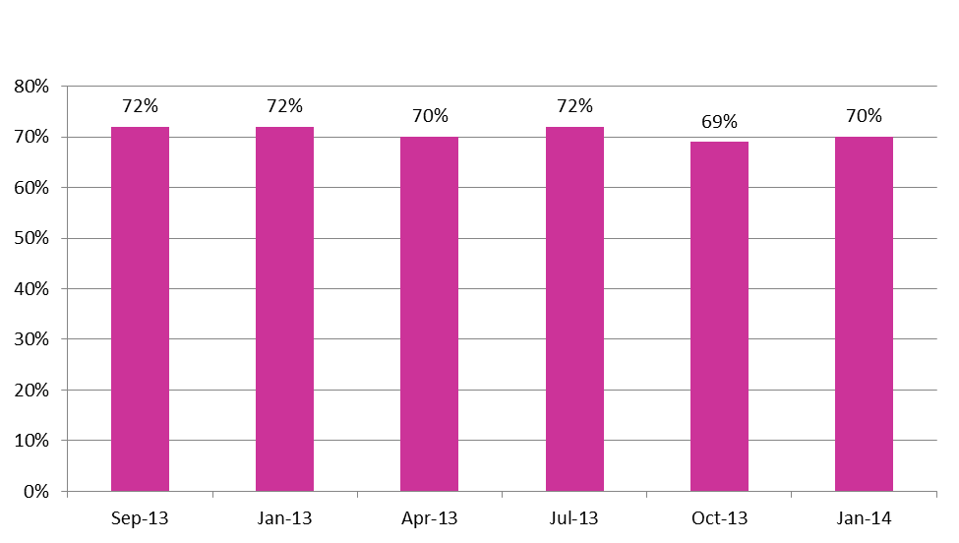
  - Respondents to the survey of senior members and officers were also positive about accountability in their authority, with 97 per cent of chief executives and 96 per cent of leaders either agreeing or strongly agreeing with the statement “local accountability is strong in my authority”.

  - Finally, the senior officials from government departments and inspectorates had increased their confidence in the theory of sector-led improvement and local accountability since the baseline interviews in 2012; but expressed a desire to see more evidence of it working in practice.

Councils owning the approach to sector-led improvement

- There are high levels of awareness of the approach to improvement and confidence in the ability of the sector to improve, as well as evidence of improvement.

  - In the survey of senior members and officers, chief executives had a high level of awareness of the approach (87 per cent had heard a lot or a moderate amount), awareness amongst leaders was lower but still fairly high (60 per cent – with a further 27 per cent having heard a little).

  - Those who were aware of the sector-led improvement approach were also very supportive. In response to the statement: “The approach to sector-led improvement is the right approach in the current context.” Eighty per cent of those chief executives who were aware agreed or strongly agreed and 68 per cent of leaders agreed or strongly agreed. The majority of remaining respondents were neutral.

  - The sector’s level of awareness about individual offers is high. The offers that leaders and chief executives were most commonly aware of were peer challenge (100 per cent of chief executives and 89 per cent of leaders were aware) and member training and development (97 per cent of chief executives and 93 per cent of leaders).

  - Authorities are confident in the skills and capacity of both their own authorities and of the sector to monitor its own performance and continuously improve. For example, over ninety per cent of heads of policy and performance, leaders and chief executives were confident in the skills and capacity of their own authority to a great or moderate extent, with chairs of scrutiny also confident, at 85 per cent. Very high levels were also confident that their authority was making advances in driving improvement (see Figure 2).

  - This confidence is borne out by the data analysis of key performance metrics. Analysis of a series of 97 metrics, across the full range of local government activity, has been carried out to provide an objective assessment of local government performance since 2010. An interim analysis shows a positive direction of travel, with approximately three quarters of these metrics having seen an improvement since 2010. More detailed reports on these indicators are currently being prepared in LG Inform, grouped by LGA board, which will allow each board to take a more in-depth view of data for their service area.

Figure 2: Proportion of senior members and officers who agree or strongly agree that ‘My authority is making advances in driving improvement’
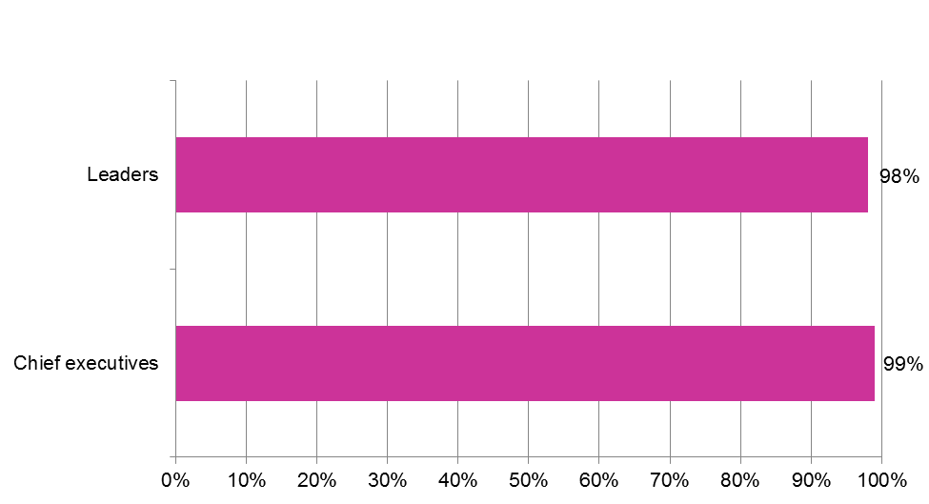

  - Focusing on the approach to sector-led improvement within adult social care specifically, through the Towards Excellence in Adult Social Care (TEASC) programme, awareness was very high amongst directors and portfolio holders of adult social care (99 per cent and 83 per cent respectively had heard a moderate amount or a lot). The majority who were aware of the approach agreed that it was the right one in the current context. Seventy nine per cent of directors agreed or strongly agreed and 71 per cent of lead members.

  - Within children’s services, 82 per cent of directors had heard a lot or a moderate amount about sector-led improvement post the Children’s Improvement Board. Of these, 60 per cent agreed it was the right approach in the current context, and a further 29 per cent were neutral.

Helpfulness of the LGA support offer

- There is also evidence to demonstrate that, as well as high levels of awareness of the offer in the sector, councils have valued the support the LGA is making available and that it has been helpful to their improvement journey.

  - In the survey of senior members and officers, 93 per cent of leaders who were aware of the offer and 93 per cent of chief executives said that the support and resources offered had had a positive impact on their authority (see Figure 3).

Figure 3: Proportion of senior members and officers who said the support and resources offered by the LGA has had a positive impact on their authority
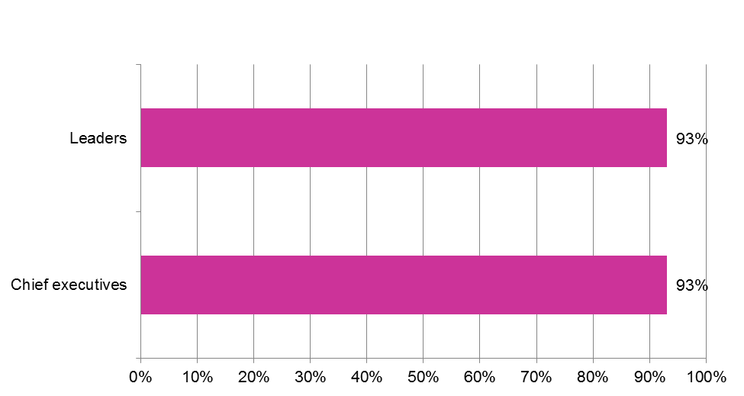
  - Ninety five per cent of chief executives who were aware of the offer and 86 per cent of leaders thought that the support and resources offered had had a positive impact on the sector more generally.

Corporate Peer Challenge
  - The more detailed evaluation of individual offers further explores their value to the sector. For example, the evaluation of the corporate peer challenge offer, concluded that:
    - Councils have been impressed with the knowledge and experience shown by peer challenge teams and the professional manner in which they conduct themselves.

    - They particularly value the fact that team members understand the complexity of working in a political environment – this helps to give councils confidence in the process.

    - Councils reported that the feedback and reports from peers teams offer challenging, constructive and honest insight.

    - Councils report that Corporate Peer Challenge has had a positive impact on their capacity to take responsibility for their own improvement. It encourages open and honest self-assessment and provides councillors, officers, staff, partners and communities with an independent review of a council’s strengths and weaknesses and the challenges it faces.

    - Peer challenge has had a positive impact on their capacity to take responsibility for their own improvement.

    - It has encouraged councils to agree clear priorities and to integrate strategic management with resource planning.

    - Peer challenge has supported councils in improving their medium term financial planning, efficiency programmes, partnership working, performance management, and engagement with partners and communities.

    - Councils that have experienced the process are strong advocates for it.

Sector-led improvement or central government intervention

  - UKRacs were commissioned to do a specific piece of independent evaluation looking at sector-led improvement compared to central government-led intervention, for turning around a council that is visibly failing. The researchers looked in detail at two case studies and concluded that sector-led improvement is better than central government intervention and that local authorities should be responsible for their own improvement and turnaround, but that where the council requires external support the sector should lead the improvement. Only where that proves insufficient should central government intervene.

  - The evaluation also demonstrated that sector-led improvement can help councils to turn themselves around, that it can be swifter to provide effective support, and that the sector does not shy away from delivering tough messages.

Adults and Children’s

  - For adult social care services and support specifically, offered to authorities through TEASC, 94 per cent of directors thought they have had a positive impact on their authority’s capacity to monitor its own performance and continuously improve; whilst 82 per cent of lead members did.

  - Awareness of the different elements of the LGA support available to help within children’s services was generally high amongst directors, particularly for the safeguarding peer review (92 per cent were aware) and diagnostics for safeguarding, care and adoption (75 per cent). Of those who had heard about the support, 93 per cent thought that there would be a positive impact on their children’s services department.

- There will be further evaluations of Knowledge Hub, LG Inform, Leadership Academy, LC Leadership Programme (formerly Leeds Castle), YouChoose, support from the Centre for Public Scrutiny and the Planning Advisory Service, as well as of sector-led improvement in children’s services.

Part 3: Conclusion

- The amount of direct support provided by the LGA to support local authorities with their journeys of improvement is being maintained at a very high level. The initial findings from the evaluation paint an extremely positive picture about the effectiveness of sector-led improvement and the support the LGA is providing. This is a significant achievement for the sector against the backdrop of increasing financial constraints and in the light of some scepticism from national stakeholders. We will be thinking carefully about how we can maximize the impact and benefit of the findings, to strengthen the arguments for stronger local accountability and the role of sector-led improvement.

- In particular, the findings help to demonstrate that improvement is not something that can be done to organisations. It has to be owned by the organisations themselves. That’s why there is always a limit to the effectiveness of inspection. The last few years have demonstrated that the sector have enthusiastically engaged in improvement activity. Taking their own improvement journey seriously but also giving back to the sector by providing support for others. The support from members and officers acting as peers on peer challenge programmes is the equivalent to millions of pounds of consultancy support.

- Our sector-led improvement approach, particularly our peer challenge programme, allows people to be more open and forward looking. The programme clearly has traction and it is far more sustainable than an approach that is inspection focussed which undoubtedly limits creatively and innovation and over time people just play the game.

Appendix A

Method for the evaluation of sector-led improvement

The key pieces of research drawn upon are:

- a telephone survey of senior members and officers conducted over the course of October and November 2013 (and a baseline survey of this group was conducted in October and November 2012);

- a series of telephone polls of representative random samples of approximately 1,000 British adults (aged 18 or over) carried out quarterly between September 2012 and January 2014;

- time series data analysis of key performance metrics for local government;

- an online survey of council heads of policy and performance conducted in October 2013 (a baseline survey of this group was conducted over the course of May and June 2012);

- a ‘perceptions audit’ comprising in-depth interviews with 15 senior officials from organisations including regulators, inspectorates and government departments during October and November 2013 (a baseline perceptions audit was conducted over the course of June and July 2012); and

- in addition, a number of small scale evaluations of the individual offers of LGA support for sector-led improvement, including a peer challenge evaluation and a study into the relative effectiveness of sector-led improvement and government-led interventions.

